University of Texas at Austin

Department of Petroleum and Geosystems Engineering

# HYDRO-MECHANIC DYNAMICS OF THERMALLY INDUCED FRACTURES

Draft for PhD proposal.

Renato Espirito Basso Poli  
(rep2656)

May 20, 2024

## Introduction

We intend to conduct a phenomenological investigation using numerical methods to clarify the impact of thermally induced stresses in oil and gas reservoir designs. Computational effectiveness emerges naturally as a requirement for assessing complex models, but it is not a primary goal.

We want to design commercially usable technologies that can empower (work together with, rather than replace) existing simulation workflows.

We want to build thermo-hydro-mechanical numerical models to investigate the dynamic behavior of fractures near injection wells and their influence on oil recovery, storage capacity, and safety. Successful models will measure each phenomenon's relevance.

### Research Question

How thermally induced fractures affect reservoir drainage, storage capacity and safety?

### Hypotheses

**H1:** Thermally induced fracture dynamics affect reservoir drainage, fluid storage, and operational safety.

**H2:** Natural fractures, if present, are the preferential planes to release the strain energy resulting from thermal stresses. The fracture network permeability responds inversely to temperature.

**H3:** Simple linear fracture transmissibility models using pressure and temperature as independent parameters are sufficient to capture the effective physical behavior to estimate reservoir drainage and fluid storage for most cases. However, the assessment of operational safety needs to incorporate more complex physics.

### Motivation

Recent research has been concerned with the numerical modeling of fracture initiation, transmissibility, and interaction with the surrounding matrix. Fracture extension has been thoroughly investigated for hydraulic fracturing in stimulation operations, but still lack an understanding of dynamic faults and fracture behavior after long-term drainage.

We refer to fracture dynamics as the phenomena expected during reservoir drainage. For example:

1. Faults and fractures may shear anywhere in the reservoir and its surroundings as the mechanical conditions depart from the initial equilibrium (risk of major oil leaks).
2. Near injecting wells, lower temperature decreases effective stress, and fractures tend to open and propagate (an increase in injectivity index).
3. Near injecting wells, fracture-to-matrix fluid leak-off increases effective stress, and fractures tend to close.
4. Near injecting wells, higher pore pressure tends to open and propagate fractures, which may extend towards the caprock and large-scale faults (risk of major oil leaks).
5. Near producing wells, the lower pressure decreases effective stress, and fractures tend to close, reducing the well productivity index and may crush the proppant.
6. Far from wells, conventional reservoir depletion decreases effective stress, and fractures tend to close.

Numerical models focused on these behaviors are typically targeted to well-stimulation designs. They consider the reservoir as simplistic continua and fracture geometry as well-behaved planes. The present project differs from the common ground in the following:

1. Many fractures are present in naturally fractured reservoirs. They interact with each other and with the surroundings, changing the overall fluid transmissibility.
2. Fracture propagation cannot be restricted to planar geometries when temperature is a significant driver (e.g., geothermal systems or long-term fluid injection) or in heterogeneous layered reservoirs. In these cases, fracture branching and swarms must be investigated.
3. Creep and plasticity cannot be neglected in many cases. For example, when salt is the caprock, as in the Brazilian pre-salt reservoirs or in salt caverns for storage.

### Original Investigation

Research papers and commercial codes on fracturing rarely discuss fracture dynamics around injection wells with significant temperature contrast. The analysis is conventionally restricted to single planar fractures, which are unsuitable in the presence of high-temperature gradients, a complex natural fracture network, or heterogeneous rocks.

### Technical Challenges

Fracture propagation is highly nonlinear, multiphysical, and multiscale (see Fig. 1). Modeling the propagation of discrete fractures on a field scale is impractical from a computational cost perspective as the fracture count grows to millions or billions of features.

We are investigating hybrid environments where the pressure, temperature, and saturation fields can be seen as boundary constraints for smaller-scale fracture propagation models. A set of parameters must be chosen to embed small-scale findings into field-scale models as an approximation.

Proper modeling of fracture nucleation can lead to a natural way of handling complex fracture geometries and branching. This is especially true in non-isothermal environments, subject to small stress contrast, where secondary and tertiary fractures are expected.

The next sections try to split the technical into manageable axes of investigation.

#### Fracture nucleation and tracking

Fracture nucleation and tracking are multi-physics phenomena that concur in distinct space-time scales. For example, as temperature and pressure diffusion characteristic time ranges from hours to days, fracture propagation may respond in seconds or faster. The physics involved includes poroelasticity, poroplasticity, pressure diffusion, energy convection and diffusion, salt creep, etc.

#### Fracture interaction in naturally fractured reservoirs

Naturally fractured reservoirs (NFR) contain many fractures and faults, in multiple scales, interacting mechanically and hydraulically with the surroundings. The computational cost of existing technology limits the number of joints that can be modeled together.

#### Scalability and computational complexity

Many researchers invested in numerical solution designs for this problem, but papers show avoidance to complex scenarios. It is rare to see the use of 3D models, fracture nucleation and tracking. We conclude that scalability is an issue for most numeric strategies.

We know that meshing is problematic, as mesh refinement explicitly capturing the phenomena leads to prohibitive computational cost, and embedding the phenomena into coarse meshes is unrealistic when fracture interaction comes to play. We believe hybrid adaptive approaches still need to be investigated.

#### Fracture multiphase imbibition

We note that many static fracture models are in use, e.g. EDFM, , LGR, etc. EDFM has emerged recently as a method to cope with large number of fractures in infra-mesh resolution. The technology has been extensively validated for single-phase workflow, but there are still open issues in the scope of naturally fractured reservoirs, multiphase flow, and capillary continuity.

### Figure 1 – Technologies to be investigated during the research

## Target Applications

We start from the fundamental assumption that *numerical modelling strategies are application specific*. Before any modeling starts, we need to frame the problem with key parameters and primary physics involved. This section describes the target applications of this work in order of priority.

#### Offshore naturally fractured carbonate reservoir

Consider an ultra-deepwater, salt as caprock, conventional heterogeneous naturally fractured carbonates, with porosity ranging from 10 to 25%, average layer permeability of to , and high stiffness (bulk modulus ). After natural depletion, the reservoir undergoes secondary enhanced oil recovery (cold water and gas flooding), with a high-temperature gradient around the injecting wells (, ). The caprock consists of thick salt layers, mainly composed of Halite.

#### Offshore sandstone reservoir

Consider an ultra-deepwater, conventional heterogeneous layered sandstone with porosity ranging from to and average layer permeability of to . After natural depletion, the reservoir undergoes secondary enhanced oil recovery (cold water and gas flooding) above the fracturing limits. The caprock consists of overlaying heterogeneous shale layers.

#### Storage in salt caverns

Consider a salt cavern built inside a Halite dome. During normal operation (years), the salt cavern is subject to cyclic pressure and temperature variations due to seasonal injection and production of the stored fluids. After abandonment, the cavern is subject to long-lasting creep (centuries), impacting the thermodynamic evolution towards equilibrium. Long-term fluid leaks through the salt due to nano-permeability and micro-fracturing of the cavern are expected.

## Expected Research Outcomes

### Modeling Outcomes

#### Identify primary parameters and physics related to fracture dynamics

Investigate and rank the most important aspects of fracture dynamics that impact oil recovery rates or safety. Propose proxy models for the applications studied, which can be included in commercial simulators and industry models.

#### Add fracture dynamics capabilities to active workflows

Although identifying primary parameters related to fracture dynamics is a product of its own (previous item), we find it important to use these findings to integrate the most important parameters into an active numerical simulation workflow.

### Operational Outcomes

#### Increase injection rates

With proper estimations of fracture dynamics, operators can safely increase injection rates, limiting the fracture propagation to a small radius around the injecting well. Alternatively, the operator may feel confident operating long-term fluid injection above the fracturing pressure. That would be the case of produced water injection, for example, which may reduce the permeability of the rock around the well.

#### Maximize salt cavern storage capacity

Enhance current simplistic design workflows of salt caverns with geomechanical considerations, especially considering long-term creep and fracture propagation constraints.

#### Optimize salt cavern abandonment

After abandonment, the salt cavern is expected to be maintenanceless and leakage-free for centuries to millenniums. Hence, proper geomechanical modeling of the cavern can support and optimize the operations, with special attention to fracture nucleation and propagation on the fracture wall.

## Maturity assessment

The maturity of the research draft described so far in this document is limited by uncertainties naturally present in early work. It seems productive to break down the problem into smaller pieces and limit the scope of individual discussion. For that, Tab. 1 lists relevant hypotheses with tentative maturity classifications. The idea is to work towards increasing the maturity of each hypothesis, gradually supporting decision-making.

### Table 1 – Maturity assessment of important hypotheses to become assumptions and hypotheses for this research.

|  |  |
| --- | --- |
| HYPOTHESIS | MATURITY |
| PHYSICS |  |
| Multiphase flow does not impact fracture propagation as long as we estimate the global temperature and pressure fields well. | Believe |
| Multiphase flow has limitations when using EDFM in NFR due to the upwind numerical strategies of the commercial simulators. | Believe. Need to investigate. |
| Temperature-driven fracture dynamics in heterogeneous reservoirs are not planar. Branching and fracture swarms cannot be neglected. | Evidence |
| Linear Poroelastic Fracture Mechanics is insufficient for fracture propagation. Plasticity and creep are relevant in many cases. | Don't know. Need to investigate |
| Creep is important to model fracture propagation in a salt layer, as it acts within minutes-to-hours. | Believe |
| Reactive transport is secondary in propagation but may fill the fracture and reduce permeability. | Believe |
| Pressure and temperature evolution *cannot* make a fracture to become a blocking path. The model may focus only in conductive fractures. | Believe |
| Fracture propagation characteristic time concur with pressure diffusion only in early times or with high-efficiency fluids, in which case fully coupling applies. Higher times are expected otherwise (weak coupling is enough) | Believe |
|  |  |
| HYPOTHESIS | MATURITY |
| NUMERICS |  |
| Only small-scale meshes can deal with the complex physics of fracture propagation. | Believe |
| EDFM works in coarse meshes and has no resolution to model physics behind fracture propagation driven by low-efficiency fluids. In fine meshes, we know better technology. | Believe. What do we learn from Lily's work? |
| Phase field models are expensive for 3D models because they require high resolution to map a 2D mesh in volumetric elements. We do not know any technology to overcome that. | Believe |
| FEM provides more mathematical flexibility than FVM and FDM to work with fracture mechanics. | Believe |
| We can numerically estimate the velocity vector at the tip of an existing fracture, which can be mapped to a point (2D domain) or a line (3D domain). | Don't know. Need to investigate. |
| We can numerically estimate a nucleation vector in any point P of the continua. | Don't know. Need to investigate. |
| Conforming meshes require remeshing but are still less expensive because they explicitly represent the fracture domain and fracture interaction is a natural outcome. | Believe |
| Non-conforming meshes cannot model fracture interaction effectively. It is unrealistic to embed mechanical interactions of complex geometry. Some technologies are ILSA, XFEM, Phase-field, SBFEM. | Believe |
|  |  |
| HYPOTHESIS | MATURITY |
| APPLICATIONS |  |
| The relaxation (opening) of natural fractures prevent fracture extension because they are strain release mechanisms. This is the case in low-temperature fluid injection, but might not happen in scenarios of stress contrasts. | Believe |
| Natural fractures closure to reservoir depletion can be handled effectively with simple tables (, e.g., CROCKTAB) in flow simulators. | Believe |
| Cold drilling fluids are enough to fracture the rock even in original pressure. This process has no time dependency and occur in stiff rocks under thermal stresses. | Believe |
| Salt cavern fracture analysis for safety needs hundreds to thousands of years. | Evidence. |
| Increase in HF effective stress due to depletion causes proppant crushing. Existing simulators tables can handle that effectively (e.g., CROCKTAB). | Believe |

## Methods

#### Numerical framework

There is a lot to understand and choose from in terms of methods. Recent work has shown that the Finite Element Method is a flexible and efficient approach to poroelasticity and fracture mechanics. Due to the geometric complexity, we want to consider iso-geometric analysis and anisotropic mesh refinement. We want to restrict mesh refinement to the fracture planes as much as possible. I understand that the diffusive characteristics of the reservoir continua favor numerical stability and demand less mesh refinement.

#### Fracture representation

Table 2 lists the alternatives to consider for the numerical representation of fractures, and Figure 2 ilustrates a possible block diagram for the simulation, with a tentative setup of their interfaces. The next sub-sections discuss the advantages and disadvantages of each methodology and the criteria to consider for technology selection.

Table 2 – Effective fracture representation techniques for mechanical and thermo-hydraulic variables.

|  |  |  |  |
| --- | --- | --- | --- |
|  |  | Mechanical | Thermo-hydraulic |
| Discrete | Conforming | Cohesive | FEM  EDFM  22 |
| Non-conforming | XFEM |
| Phase-field |
| Level-set |
| Hybrid | Multiscale |
| Smeared | Non-conforming | Smeared | FEM  22 |

Figure 2 – Interfaces between solvers. Each box is a fully coupled solution of the variables in parentheses.

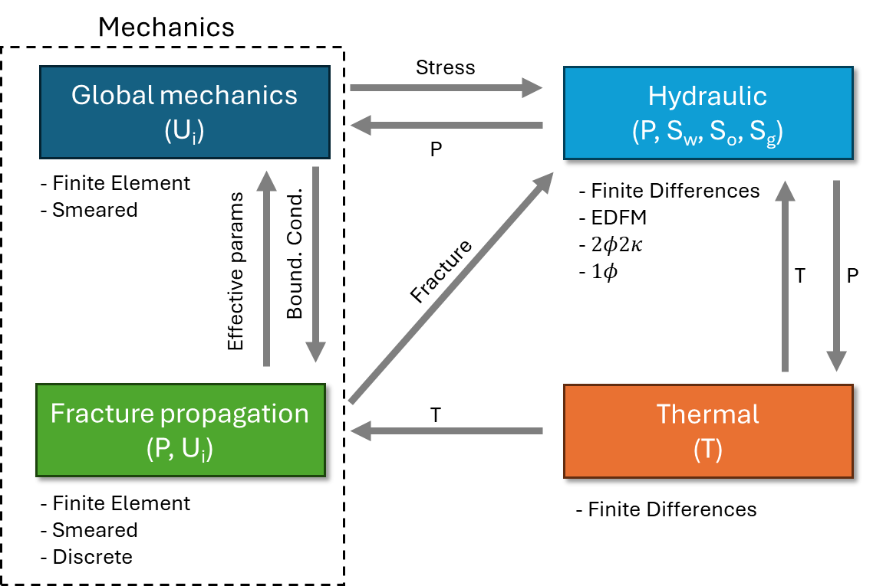

##### Discrete or Smeared

Discrete fractures are explicit representations of rock joints. It is relatively straightforward to assign fracture-domain physics to it and map the fracture's geometry. Mapping the mechanical characteristics of each feature to EDFM or discrete FEM representation is also natural. For natural fractures, however, discrete representations carry a lot of uncertainty because there is no clear correlation between geometry and its transmissibility and because it occurs on multiple scales.

Smeared fractures are the representation of fractures as an equivalent mechanical continuum. It is a popular method in concrete mechanics. It represents collections of fractures as an equivalent continuum but may fail in detailed physics targeting phenomenological small-scale investigations. Homogenized attributes control the geometric evolution, and transmissibility is controlled by fracture density and an overall understanding of the local geology. It may be seen as the mechanical analog of the hydraulic models. As such, the mapping between smeared fractures and is trivial if a reliable calibration procedure is applied.

##### Discrete conforming, non-conforming or hybrid

Conforming fractures are the ones mapped as sides of the elements of the continua as elements of reduced dimensions (1D elements in a 2D domain or 2D elements in a 3D domain). The advantage of conforming fractures is explicitly separating the fracture and continuum domains. A specific set of equations is assigned to each domain, which are weakly coupled at the domain boundaries, similar to DG (Discontinuous Galerkin) strategy.

Fracture propagation dynamics are split in two: (i) update the mesh with the proper domain assignment in a moving boundary problem; (ii) evaluate the fracture propagation only at the fracture domain. Mesh manipulation and tracking the global fracture path is not trivial, however.

In non-conforming approaches, the fracture evolution is embedded into the continua. The coexistence of fracture and continua physics in the same numerical entity increases complexity when considering geometrically sophisticated scenarios. Hydraulic-to-natural fracture interactions, for example, are challenging to implement using non-conforming methods.

Phase-field methods intend to split the domains using a phase variable. However, as the phase variable is mapped into the continua, it demands a fine mesh and is computationally expensive for large problems. The idea of methods to keep the fractures in a domain with reduced dimensions looks more efficient.

Hybrid approaches enable the discrete representation of fracture dynamics in a secondary small-scale mesh, which is embedded into a larger-scale mesh as effective simplified enhancements. The larger scale mesh defines the boundary conditions for the small-scale simulations and interactions between possibly many fractures propagating simultaneously. The implementation complexity of this approach increases as many datastructures are used simultaneously.

##### Thermo-hydraulic coupling

The degree to which the mechanics are coupled to the temperature and hydraulic diffusion must be determined a priori. The pressure and fracture geometry are strongly coupled even in thermally induced fracture propagation, because they have similar characteristic time responses. However, temperature and fluid saturation show a longer characteristic time when responding to fracture propagation and may likely be solved sequentially.

The multiphase solution is complex but assumed to be weakly coupled to fracture propagation. It makes sense to seek an interface with existing Finite Differences (FD) simulators, which can also solve the temperature and complex thermodynamics. The interface between the simulators can use different technologies, namely , or EDFM.

The idea is to design the fracture propagation engine to solve only displacements and pressure, fully coupled, taking temperature and fluid saturation as constants in time.

## Worksplit

This section proposes a tentative worksplit to refine and prioritize, and a tentative timeline (Tab. 2).

#### EDFM Review *(ongoing)*

Investigate and write a paper on the state-of-the-art of fracture modeling and latest contributions in EDFM techniques.

#### Homogenization of mechanical parameters in fractured poroelastic media *(ongoing)*

Validate the simulator and discuss issues regarding the macroscale mechanical behavior of an NFR with varied fractured densities. Compare with existing methodologies. Use this effort to test and improve the simulator.

#### Multiphase flow models in NFRs using EDFM *(ongoing)*

Validate multiphase flow models in EDFM, comparing to reference numerical solutions. Provide criteria for technology selection for conventional NFRs (explicit LGR, , , EDFM or MINC)

#### Stress assessment

Use the simulator or other tool to assess stress dynamics around the injection wells. Stress calculations are not trivial. Having the stress as a variable in the flow simulator can immediately lead to the incorporation of stress-dependent parameters. A good understanding of the stress is essential to designing fracture initiation numerics.

#### Estimate temperature-dependent stress

Repeat the same effort, adding temperature evolution. In the single-phase environment, it is feasible to use the same FEM engine to estimate the temperature. Verify to what extent existing fractures can relax strain energy and prevent fracture propagation. Provide stress analysis on the tip of the fractures and verify whether they are stable and in which conditions they would propagate.

#### Propagate fractures

Add propagation capabilities to the model, considering multiple fracture paths known a priori. Use cohesive elements or a smeared approach.

#### Fracture initiation and branching

Progress from the last item towards tracking the fracture paths. Remeshing might be needed. Engines are likely needed: 1) discover the potential fracture paths; 2) do the remeshing; 3) DG in time to the marching algorithm.

#### Plasticity and creep

Plasticity and creep pose significant nonlinearity to the models. This may cost significant implementation effort.

Table 2 – Tentative timeline *(draft)*

|  |  |
| --- | --- |
| Year/sem |  |
| 2024/1 | EDFM Review  Define research scope.  Homogenization of Biot parameters |
| 2024/2 | Literature review.  Write and defend the proposal.  Stress assessment.  Smeared fracture propagation  Application: estimate the effect of thermal fractures in production |
| 2025/1 | Discrete fracture propagation.  Fracture initiation and branching.  Application: heterogeneous media and branching |
| 2025/2 | Plastic and creep environments.  Application: fracture propagation in salt rock (caprock and caverns) |
| 2026/1 | Application: integration with EDFM and finite difference simulators |
| 2026/2 | Wrap up results. |
| 2027/1 | Write dissertation. |